**Sumanth Acharya**

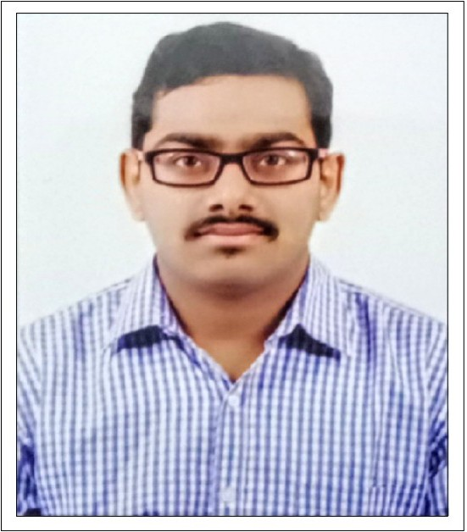

|  |  |
| --- | --- |
| **Title:** | A4 Analyst |
| **Location:** | Bangalore, India |
| **Languages:** | Kannada(native),Hindi (fluent),English (fluent) |

# Experience Summary

Work with determination & focused to quality in every task. Good Team player with positive mindset. Good team spirit.

**KEY SKILLS:**

* **Functional:** Project Management, Team Building, Good Communication and Interpretation skills
* **Technical:** Core Java, AWS, Spring Framework, Oracle SQL, MongoDB, DevOps, Docker, HTML, Javascript

# Higher Education

|  |  |  |  |  |  |  |  |  |  |
| --- | --- | --- | --- | --- | --- | --- | --- | --- | --- |
| |  | | --- | | **Academics (Specialization)** | | |  | | --- | | **School / College** | | |  | | --- | | **Board / University** | | |  | | --- | | **Year of Passing** | | |  | | --- | | **Score** | |
| |  | | --- | | B.E in Electronics and Communication | | |  | | --- | | Sai Vidya Institute of Technology | | |  | | --- | | Visvesvaraya Technological University | | |  | | --- | | 2018 | | |  | | --- | | 63.75 % | |
| |  | | --- | | Pre-University College | | |  | | --- | | St.Claret Pre University College | | |  | | --- | | Karnataka State P.U Board | | |  | | --- | | 2014 | | |  | | --- | | 74.5 % | |
| |  | | --- | | 10th Standard | | |  | | --- | | Divine English School | | |  | | --- | | ICSE | | |  | | --- | | 2012 | | |  | | --- | | 74% | |